

2016 Community Cultural Activity in Miaoli

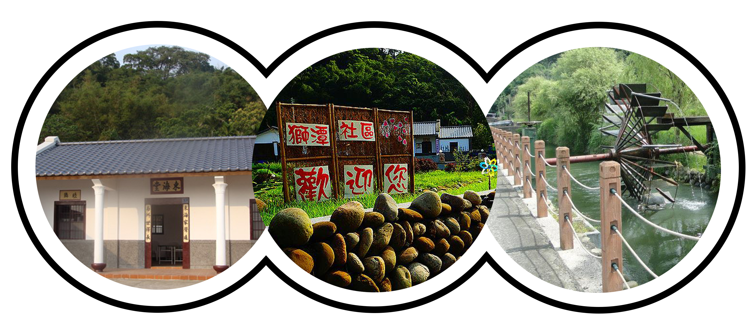
苗栗縣頭屋鄉獅潭社區
Shitan Community
Shitan community is located at the northwest side of Miaoli. Ancients obtained water from Houlong River by waterwheel, so people in Shitan community engage in agriculture. The people here are Hakkas, they are hardworking and thrifty. We will take you to visit natural landscape in Shitan community and step into reservoir with your bare feet to experience claims digging. Learning how to make Hakka mochi to blend into Hakka culture!

- Location: Shitan Community, Touwu Township, Miaoli County(苗栗縣頭屋鄉獅潭社區)
- Date: April 30th, 2016
- Sponsor: Ministry of Education
- Organizer: Taiwan Hostfamily Program

2016 Community Cultural Activity in Tainan
- Participant:
(1) Host families
(2) International students currently attending a university/institution in Taiwan
*Free for all international students and host families
- Meeting point: Miaoli Railway Station (苗栗火車站)
- Register: Please register online http://www.hostfamily.org.tw/en/news/85-8982
- Deadline: April 17th, 2016
- Contact Information:
Taiwan Hostfamily Program (Southern Taiwan University of Science and Technology)
Gianna Hsu
Tel: 06-2533131 #1603
E-mail: hostfamily@mail.stust.edu.tw
- Notes:
(1) Please bring your water bottle, rain gear and sun care products.
(2) Remember to wear comfortable, casual clothes and shoes.
Time | Content of Activity
11:15 | Gathering at Miaoli Railway Station
11:35-11:55 | Leave for Shitan Community
12:00-12:10 | First time to meet your host family
12:10-13:10 | Community-style lunch with your host family
13:20-15:20 | Community guided tours; Go claims digging(step into reservoir with bare feet); Hakka mochi DIY
15:30-16:30 | Share your one day activity experience with your host family
16:30- | Leave for Miaoli Railway Station
(3) We will go claims digging, so we suggest you to bring your slippers and shorts to change.

